**WITH NOISE AND WITH FILTER FUZZY**

**Image set:**

|  |
| --- |
| **Image 1:-0.1 % Noise** |

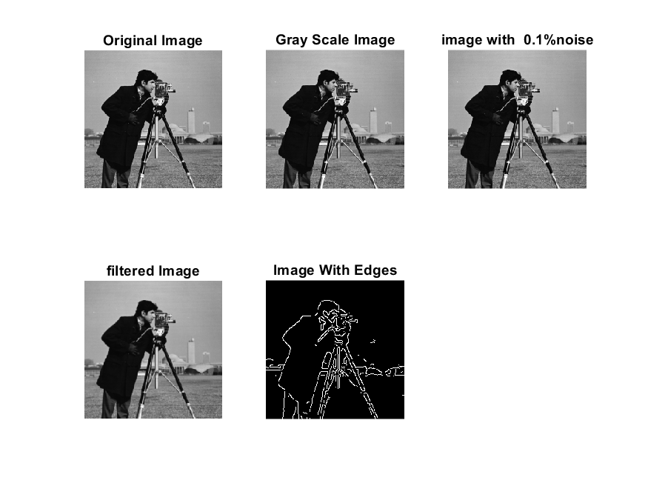

**Image 2:-10 % Noise**

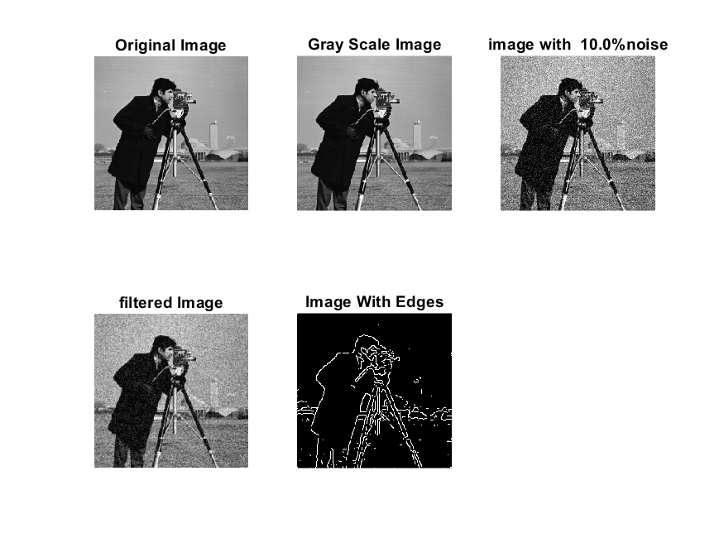

**Image 3:-20 % Noise**

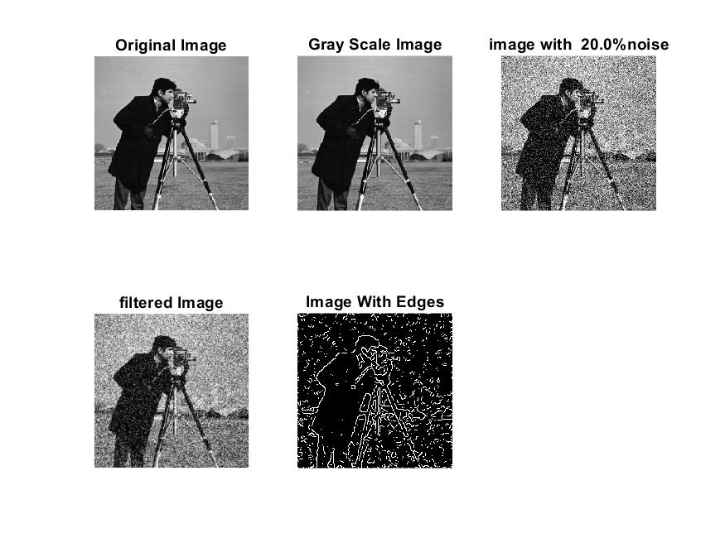

**Image 4:-30 % Noise**

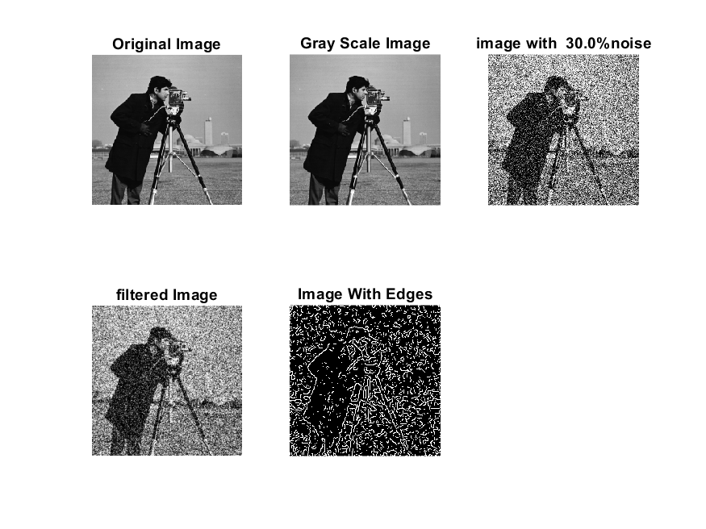

|  |
| --- |
| **Image 5:-40 % Noise** |

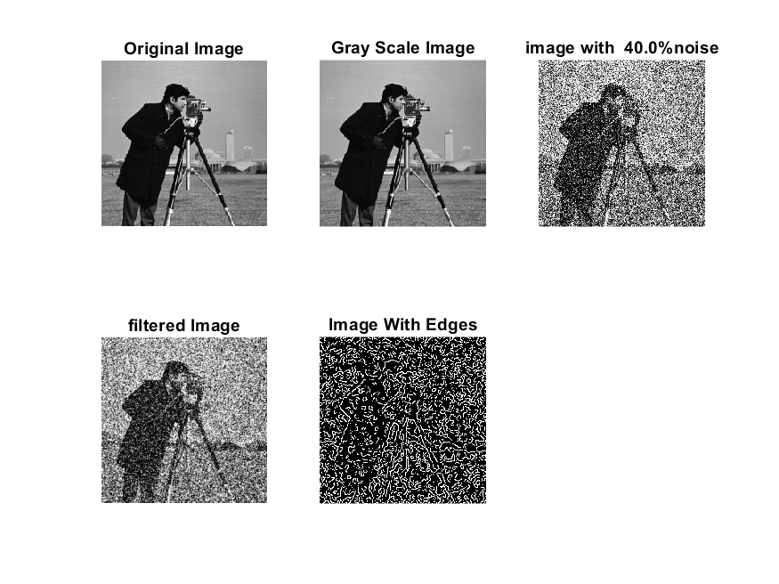

**Image 6:-50 % Noise**

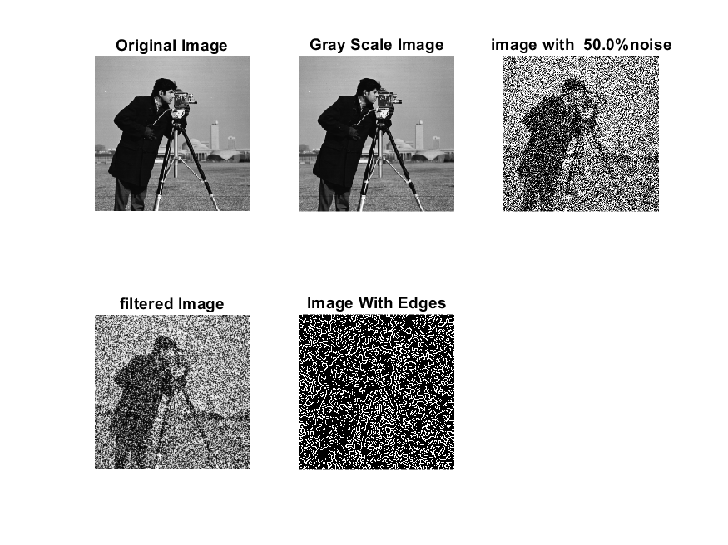

**Image 7:-60 % Noise**

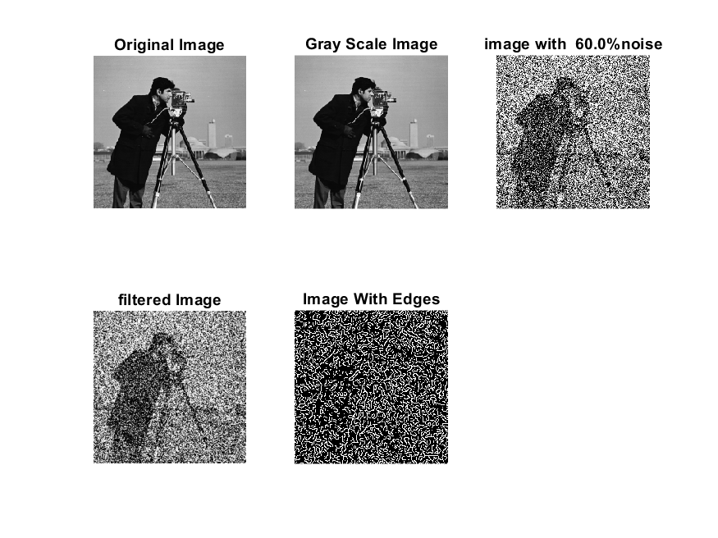

**Image 8:-70 % Noise**

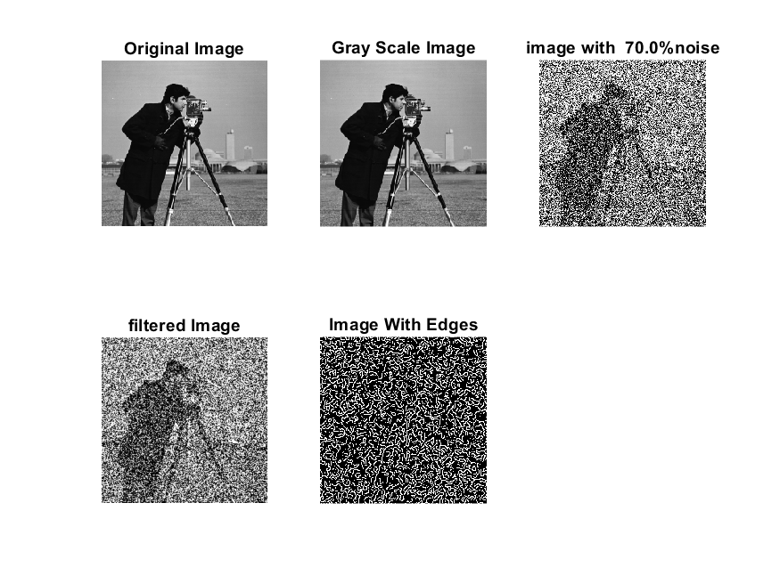

**Image 9:-80 % Noise**

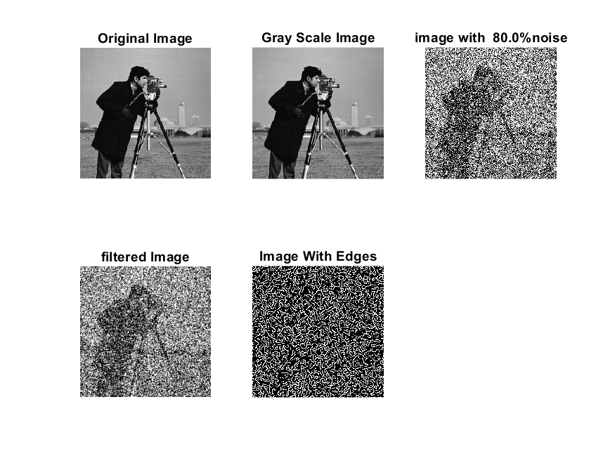

**DATA FILES**

**Image 1:-Noise0.1**

Original image ideal values:

IM1 image entropy:2.848313e-01

IM1 image mean:0.049632

Ground truth image entropy:0.717315

Ground truth image mean:0.197705

entropy between imt and im1 :0.674838

MSE between imt and im1 :0.207162

Average Difference between imt and im1 :0.148073

Maximum Difference between imt and im1 :1.000000

True Positive values:1026.000000

False Positive values: 1509.000000

True Negative values:39469.000000

False Negative values:9072.000000

Accuracy value: 0.792838

F Measure values:0.162432

Peak Signal-to Noise Ration value: 6.836902

Signal-to Noise Ration value: -6.002574

percentage of pixels that were correctly detected (Pco): 0.101604

The percentage of pixels that were not detected (Pnd):0.898396

the percentage of false alarm: (Pfa):0.149436

Euclidean Distance Value :9.249360

**Image 1:-Noise10**

Original image ideal values:

IM1 image entropy:3.020909e-01

IM1 image mean:0.053743

Ground truth image entropy:0.717315

Ground truth image mean:0.197705

entropy between imt and im1 :0.671057

MSE between imt and im1 :0.207867

Average Difference between imt and im1 :0.143962

Maximum Difference between imt and im1 :1.000000

True Positive values:1113.000000

False Positive values: 1632.000000

True Negative values:39346.000000

False Negative values:8985.000000

Accuracy value: 0.792133

F Measure values:0.173324

Peak Signal-to Noise Ration value: 6.822151

Signal-to Noise Ration value: -5.656930

percentage of pixels that were correctly detected (Pco): 0.110220

The percentage of pixels that were not detected (Pnd):0.889780

the percentage of false alarm: (Pfa):0.161616

Euclidean Distance Value :10.102384

**Image 1:-Noise20**

Original image ideal values:

IM1 image entropy:4.754417e-01

IM1 image mean:0.102044

Ground truth image entropy:0.717315

Ground truth image mean:0.197705

entropy between imt and im1 :0.651218

MSE between imt and im1 :0.238703

Average Difference between imt and im1 :0.095661

Maximum Difference between imt and im1 :1.000000

True Positive values:1559.000000

False Positive values: 3653.000000

True Negative values:37325.000000

False Negative values:8539.000000

Accuracy value: 0.761297

F Measure values:0.203658

Peak Signal-to Noise Ration value: 6.221419

Signal-to Noise Ration value: -2.872310

percentage of pixels that were correctly detected (Pco): 0.154387

The percentage of pixels that were not detected (Pnd):0.845613

the percentage of false alarm: (Pfa):0.361755

Euclidean Distance Value :14.499703

**Image 1:-Noise30**

Original image ideal values:

IM1 image entropy:6.573051e-01

IM1 image mean:0.169825

Ground truth image entropy:0.717315

Ground truth image mean:0.197705

entropy between imt and im1 :0.624565

MSE between imt and im1 :0.284047

Average Difference between imt and im1 :0.027880

Maximum Difference between imt and im1 :1.000000

True Positive values:2132.000000

False Positive values: 6542.000000

True Negative values:34436.000000

False Negative values:7966.000000

Accuracy value: 0.715953

F Measure values:0.227147

Peak Signal-to Noise Ration value: 5.466093

Signal-to Noise Ration value: -0.660159

percentage of pixels that were correctly detected (Pco): 0.211131

The percentage of pixels that were not detected (Pnd):0.788869

the percentage of false alarm: (Pfa):0.647851

Euclidean Distance Value :20.161483

**Image 1:-Noise40**

Original image ideal values:

IM1 image entropy:7.721473e-01

IM1 image mean:0.226662

Ground truth image entropy:0.717315

Ground truth image mean:0.197705

entropy between imt and im1 :0.610213

MSE between imt and im1 :0.329254

Average Difference between imt and im1 :-0.028957

Maximum Difference between imt and im1 :1.000000

True Positive values:2429.000000

False Positive values: 9148.000000

True Negative values:31830.000000

False Negative values:7669.000000

Accuracy value: 0.670746

F Measure values:0.224129

Peak Signal-to Noise Ration value: 4.824684

Signal-to Noise Ration value: 0.593607

percentage of pixels that were correctly detected (Pco): 0.209813

The percentage of pixels that were not detected (Pnd):0.662434

the percentage of false alarm: (Pfa):0.790187

Euclidean Distance Value :20.029598

**Image 1:-Noise50**

Original image ideal values:

IM1 image entropy:8.201840e-01

IM1 image mean:0.255697

Ground truth image entropy:0.717315

Ground truth image mean:0.197705

entropy between imt and im1 :0.600681

MSE between imt and im1 :0.350732

Average Difference between imt and im1 :-0.057992

Maximum Difference between imt and im1 :1.000000

True Positive values:2622.000000

False Positive values: 10438.000000

True Negative values:30540.000000

False Negative values:7476.000000

Accuracy value: 0.649268

F Measure values:0.226444

Peak Signal-to Noise Ration value: 4.550243

Signal-to Noise Ration value: 1.117078

percentage of pixels that were correctly detected (Pco): 0.200766

The percentage of pixels that were not detected (Pnd):0.572435

the percentage of false alarm: (Pfa):0.799234

Euclidean Distance Value :19.125542

**Image 1:-Noise60**

Original image ideal values:

IM1 image entropy:8.444958e-01

IM1 image mean:0.272124

Ground truth image entropy:0.717315

Ground truth image mean:0.197705

entropy between imt and im1 :0.593816

MSE between imt and im1 :0.361794

Average Difference between imt and im1 :-0.074419

Maximum Difference between imt and im1 :1.000000

True Positive values:2759.000000

False Positive values: 11140.000000

True Negative values:29838.000000

False Negative values:7339.000000

Accuracy value: 0.638206

F Measure values:0.229945

Peak Signal-to Noise Ration value: 4.415384

Signal-to Noise Ration value: 1.387482

percentage of pixels that were correctly detected (Pco): 0.198503

The percentage of pixels that were not detected (Pnd):0.528024

the percentage of false alarm: (Pfa):0.801497

Euclidean Distance Value :18.898304

**Image 1:-Noise70**

Original image ideal values:

IM1 image entropy:8.539987e-01

IM1 image mean:0.278937

Ground truth image entropy:0.717315

Ground truth image mean:0.197705

entropy between imt and im1 :0.590276

MSE between imt and im1 :0.365867

Average Difference between imt and im1 :-0.081232

Maximum Difference between imt and im1 :1.000000

True Positive values:2829.000000

False Positive values: 11418.000000

True Negative values:29560.000000

False Negative values:7269.000000

Accuracy value: 0.634133

F Measure values:0.232409

Peak Signal-to Noise Ration value: 4.366773

Signal-to Noise Ration value: 1.494881

percentage of pixels that were correctly detected (Pco): 0.198568

The percentage of pixels that were not detected (Pnd):0.510213

the percentage of false alarm: (Pfa):0.801432

Euclidean Distance Value :18.904099

**Image 1:-Noise80**

Original image ideal values:

IM1 image entropy:8.677318e-01

IM1 image mean:0.289236

Ground truth image entropy:0.717315

Ground truth image mean:0.197705

entropy between imt and im1 :0.585077

MSE between imt and im1 :0.372171

Average Difference between imt and im1 :-0.091530

Maximum Difference between imt and im1 :1.000000

True Positive values:2931.000000

False Positive values: 11842.000000

True Negative values:29136.000000

False Negative values:7167.000000

Accuracy value: 0.627829

F Measure values:0.235696

Peak Signal-to Noise Ration value: 4.292576

Signal-to Noise Ration value: 1.652333

percentage of pixels that were correctly detected (Pco): 0.198402

The percentage of pixels that were not detected (Pnd):0.485142

the percentage of false alarm: (Pfa):0.801598

Euclidean Distance Value :18.886698